Accessible information about stroke and aphasia

What is a stroke
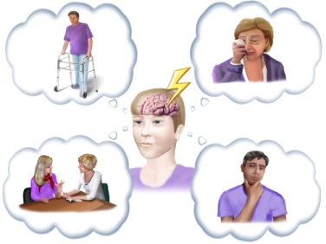  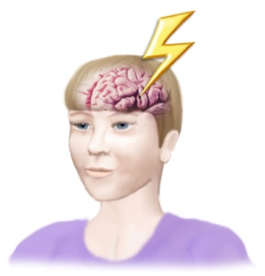 | The brain controls everything we do  movement  emotions  communication  thinking  The brain needs blood  Blood keeps the brain working  The blood supply can stop  Then the brain is damaged  This can happen suddenly  This is called a stroke
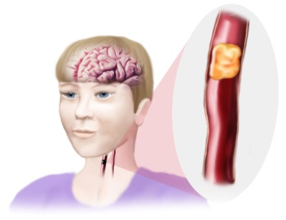 | A stroke can happen in two ways  Arteries carry blood to the brain  A blood clot (thrombus) can block an artery  Then no blood gets to the brain  This damages the brain part that the artery supplies  This is called an Ischemic stroke
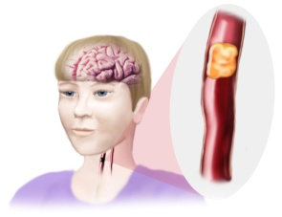 | The walls of a blood vessel may be weak  They can burst  Then the blood spreads into the brain  This damages the brain  This is called a brain haemorrhage
Each brain part controls different things

The effects of a stroke are different

This depends on the area damaged

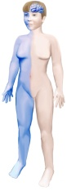  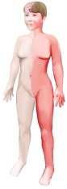 | The left side of the brain  controls the right side of the body  The right side of the brain  controls the left side of the body
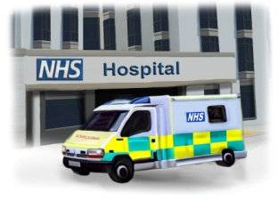 | After a stroke people go to hospital  They usually go in an ambulance
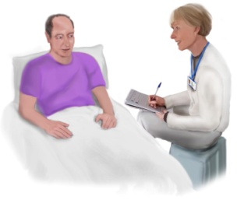 | The staff find out about any difficulties
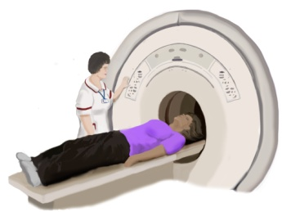 | They give a brain scan  This shows why the stroke happened  Was it caused by a bleed in the brain?  Was it caused by a clot?
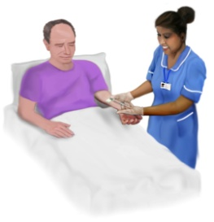  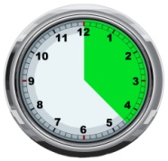  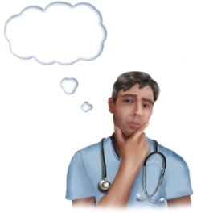 | If it is a clot Thrombolysis may help  This is an injection  It will break up the clot  The blood flows freely again  Thrombolysis has to happen in the first  4 1/2 hours  Not everyone can have thrombolysis  The doctor will decide
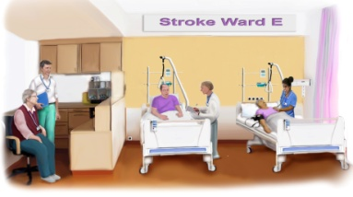 | Hospitals have a stroke ward  The staff are experts in stroke  People go there as soon as possible

Finding out what has happened

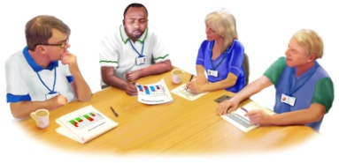  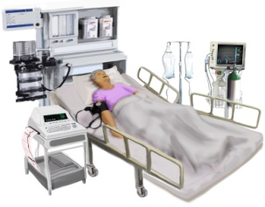  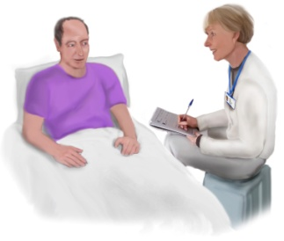 | The stroke staff are a team  sometimes called the multidisciplinary team  They watch for any change  They give care and help  They ask questions and do tests  They find out about problems  They decide if further tests are needed
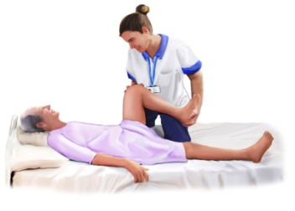  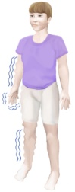  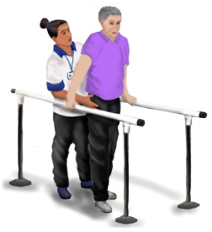  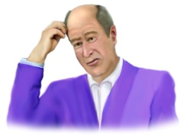  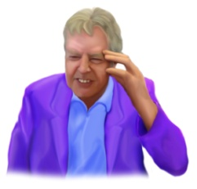  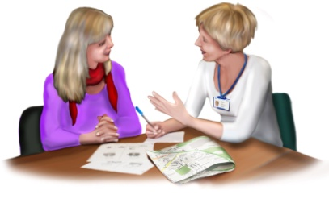  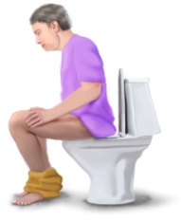  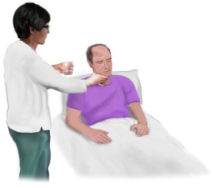  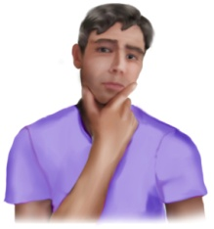  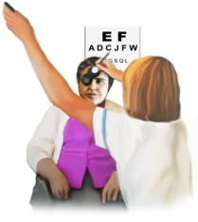  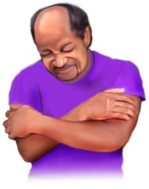 | The tests will look at  Movement of the arms and legs  numbness  balance  confusion  headache  communication  bladder and bowel control  eating and drinking  thinking  eyesight  pain
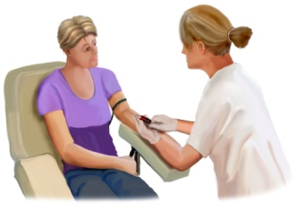  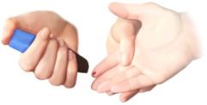  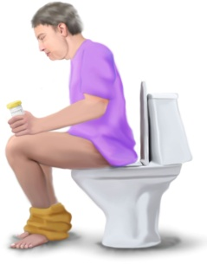  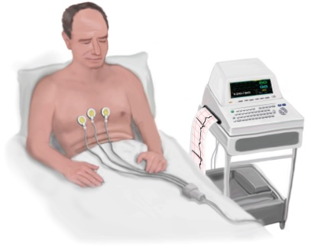  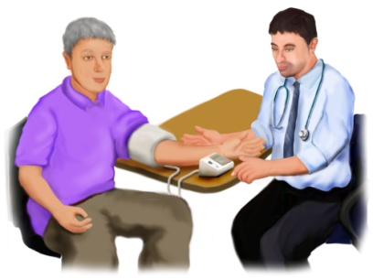  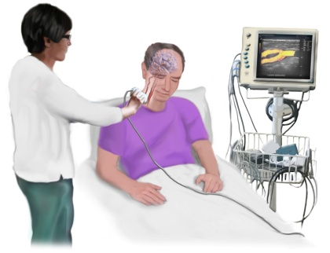  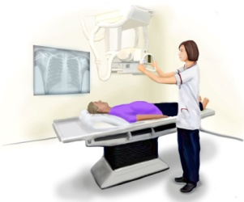  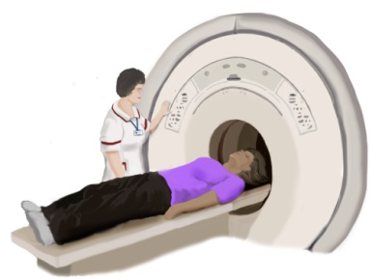  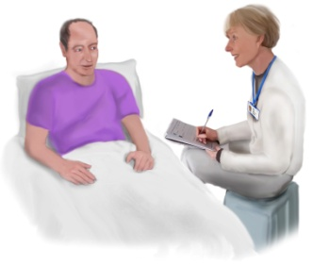  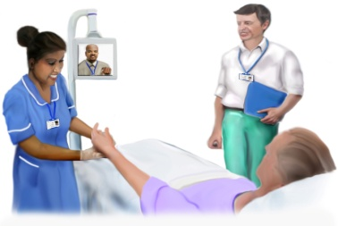  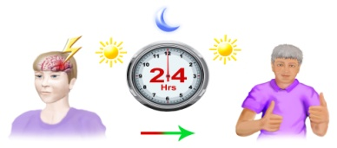  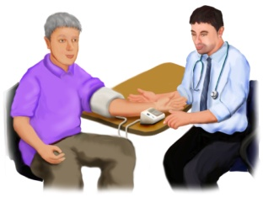  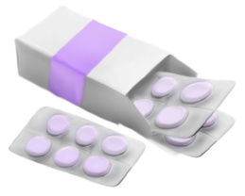 | The staff may need to do medical tests  These give more information  They may need  blood tests  urine tests  ECG (Electrocardiogram)  blood pressure checks  carotid ultrasound  X Ray  Scan  The staff also ask questions  Sometimes telemedicine is used  This uses technology  It gets help from specialists  The specialists are not in the hospital  For some people the signs of a stroke go away within 1 day (24 hours )  This is called a Transient Ischemic Attack or TIA  People with a TIA still need to have regular checks by their doctor  They may need to have medicine

Treatment

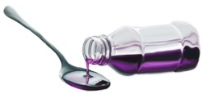  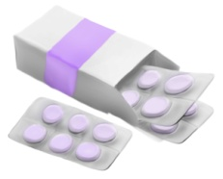  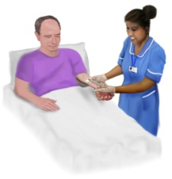  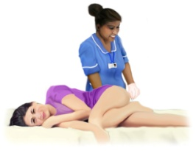  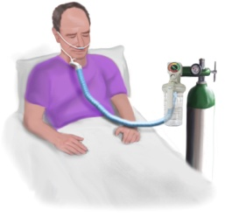 | Medicine may help  syrup  tablets  injections  suppository  oxygen
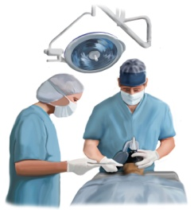  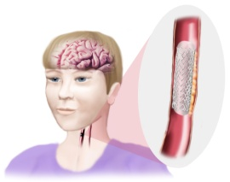 | Sometimes a surgeon will operate  A stent may help some people  A stent is a small mesh tube  It goes inside narrow or weak arteries  It helps keep the arteries open  This lets the blood flow through

Hospital staff and how they help

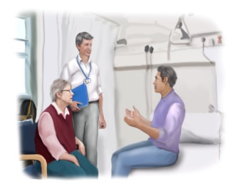  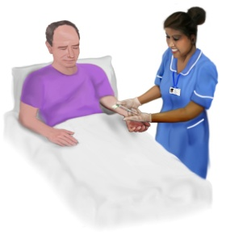 | A stroke consultant makes the medical decisions  They manage the care in hospital  A stroke nurse gives medical care  They watch for any change  This is called monitoring
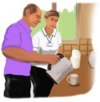  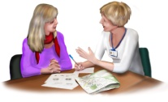  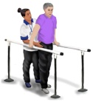 | Rehabilitation is help to get better  It is also called therapy  There are therapists on the stroke ward  They are experts in stroke  People may not need help from all therapists
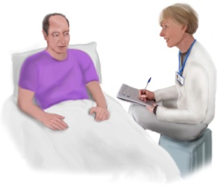  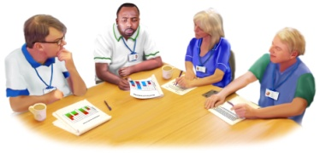  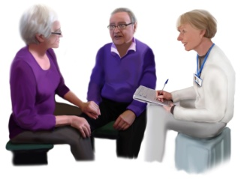  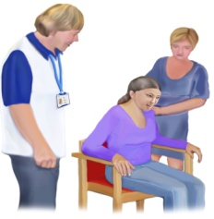    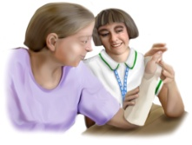   | The therapists do assessments  They find out more about any difficulties  They plan for therapy  They talk to any family  They tell them about the therapy  They teach how to help  The therapy plan may have exercises  These should be repeated often  Therapists use equipment in therapy  They may give equipment to use all the time
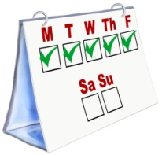  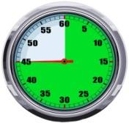  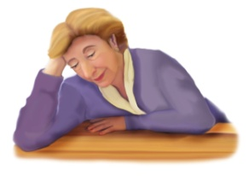 | Therapy should happen 5 times a week  It should last 45 minutes each time  Some people find this too tiring  They will do as much as they can

Physiotherapist

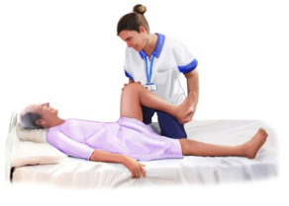  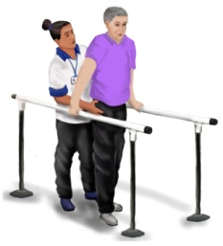  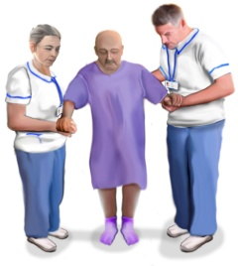  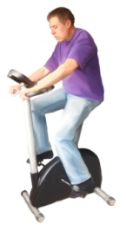  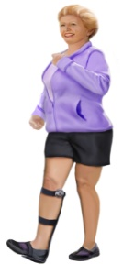  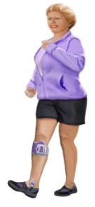  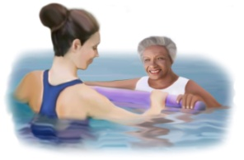 | A physiotherapist checks movement  They are sometimes called a physio  They check arms and legs  They check coordination  They check if muscles are weak  They check balance  They check walking  They may use equipment  such as an exercise bike  or a treadmill  They may give equipment  They may give a foot splint  This helps with walking  Functional Electrical Stimulation (FES)  This is a small electric shock  The shock is given to the nerves  This helps movement of muscles  Physiotherapy is sometimes in a swimming pool

Occupational therapist

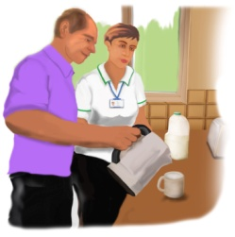  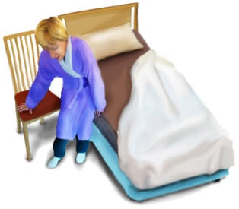  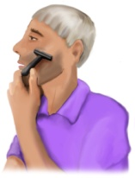  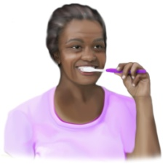  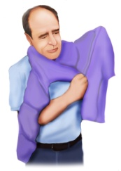  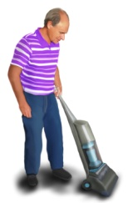  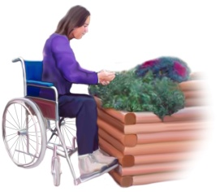  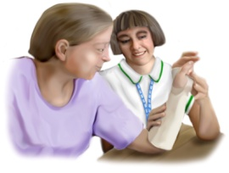  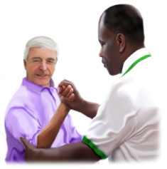 | An Occupational Therapist helps with activites  They are sometimes called an OT  They help people be independent if possible  They help people with everyday activities  After stroke it can be hard to  make drinks and meals  get out of bed  keep clean and tidy  clean the mouth and teeth  get dressed  look after the house  It may be hard to do the same hobbies  An occupational therapist may give equipment to help  An occupational therapist helps with relearning skills

Speech and language therapist

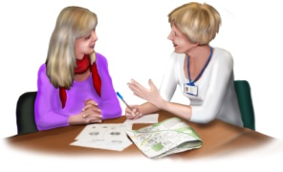  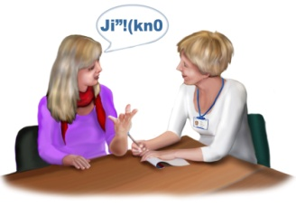  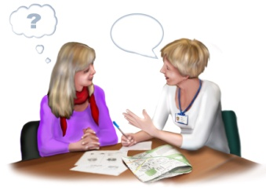  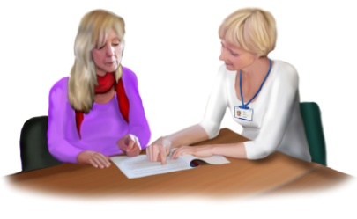  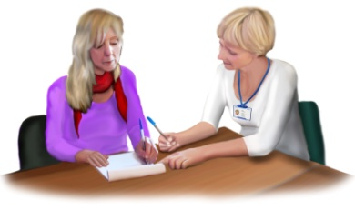  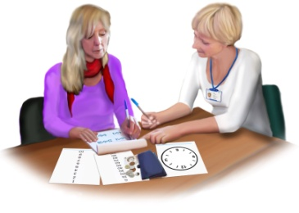  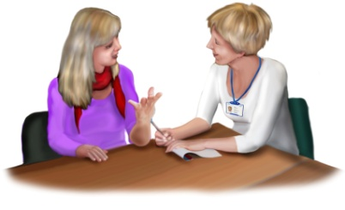  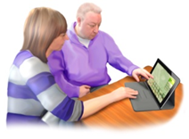  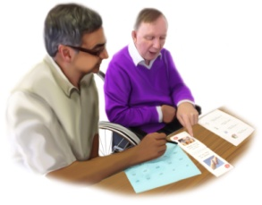 | A speech and language therapist helps communication  Stroke can affect communication  It can be hard to  speak clearly  find the right words  put ideas into sentences  understand other people  read  write  use numbers and money  A speech and language therapist may give exercises  They may teach different ways of communicating  They may use equipment  They help family or carers to communicate  They may arrange conversations  These will be with people trained to help
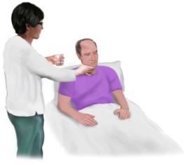  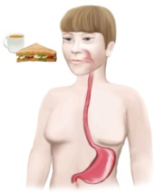  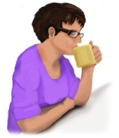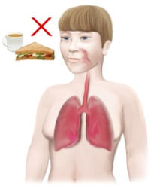  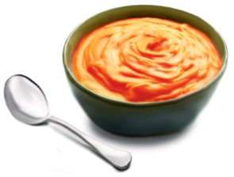  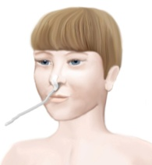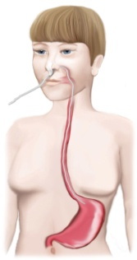  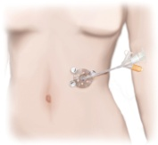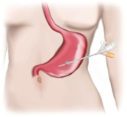 | A speech and language therapist  helps with eating and drinking  They check for difficultity swallowing  Food and drink should go into the stomach  After a stroke  sometimes the swallow does not work  Food might go into the lungs  Drink might go into the lungs  Some food and drink is easier  Some people cannot eat or drink  They may get food through a tube  This goes through the nose  It goes into the stomach  It is called a NasoGastric Tube NG tube  They may get food directly into the stomach  This is called Percutaneous Endoscopic Gastrostomy PEG

Other hospital staff
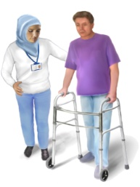  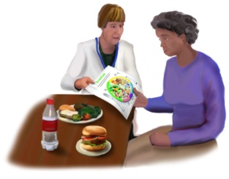  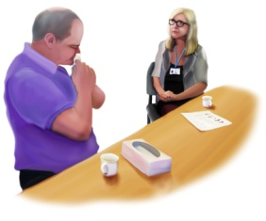  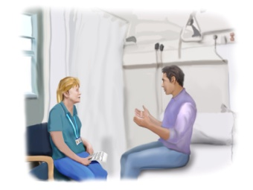    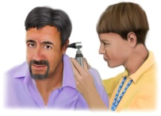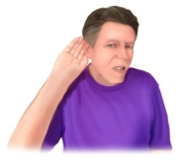  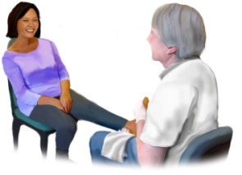  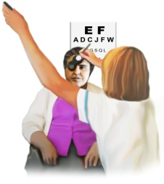 | Rehabilitation assistants help practice therapy  A dietitian helps people get the right food  This helps them keep healthy  A psychologist helps with emotions  A psychologist helps with thinking  A social worker organises help from social services  The help is for after hospital  A pharmacist helps with medicines  An audiologist helps with hearing  A podiatrist helps with feet  An optometrist helps with eyesight

Leaving hospital

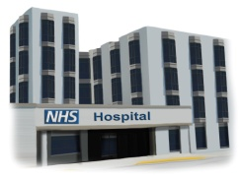  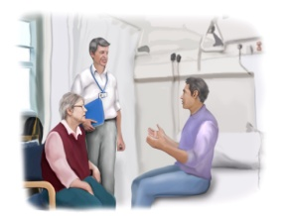  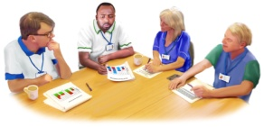  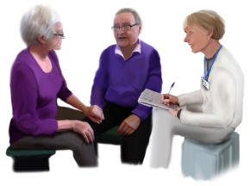  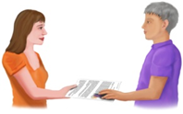  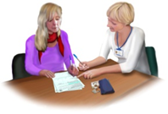  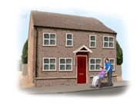 | At first rehabilitation happens in hospital  The stroke team plan for leaving hospital  The rehabilitation team also plan  They plan for therapy after hospital  Any family or carers will help plan  The stroke team give patients the plan  The plan covers lots of things  It may include  how to claim benefits  information about housing
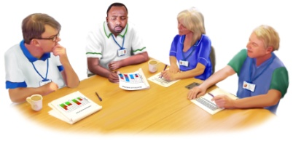  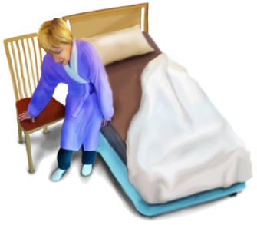  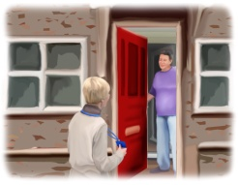  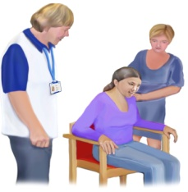  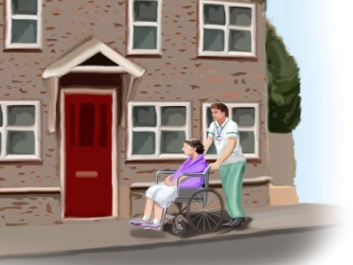  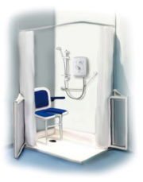  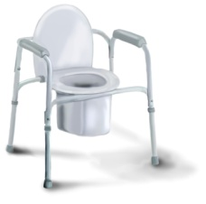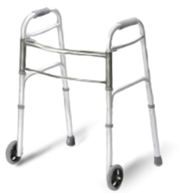  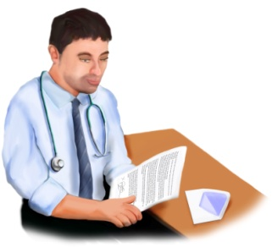 | There is support and therapy after hospital  This happens wherever people live  There are different ways of organising this  Some areas have a team of specialist stroke therapists  They are called the Community Stroke Team  Some hospitals have an Early Supported Discharge Team  Some people can move easily from a chair to a bed  They can leave hospital quite soon  These people get support and therapy at home instead  Family may help at home  The therapists will train them  Stroke can make it hard to live in the same way  Staff will check the home  They check it is safe  They check it is suitable  They may take people to visit their home  Special equipment might help  This will be ready for going home  The staff explain about medicine for going home  The hospital staff share information about your stroke  They tell the doctor (GP)  They tell the community stroke team

At home

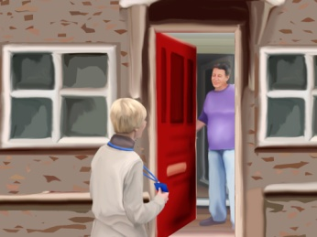  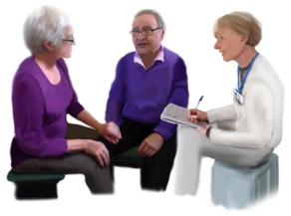  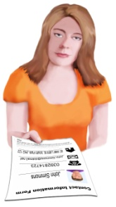  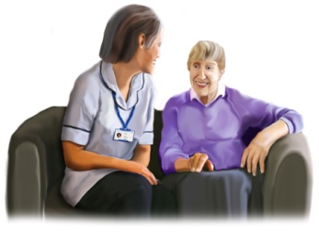 | Therapists visit at home  They visit within 3 days of leaving hospital  They plan the support  They plan the therapy  They ask about any changes  They ask about any new difficulties
The therapists say who to contact for help

They give a name

They give a telephone number

There are people who give support

They help people manage at home

This is their job

They are sometimes called paid carers

The effects of the stroke

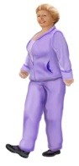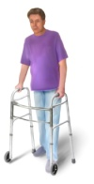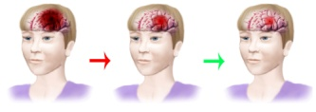  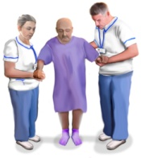  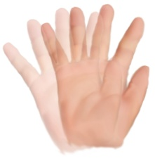    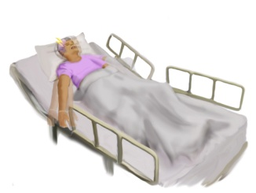  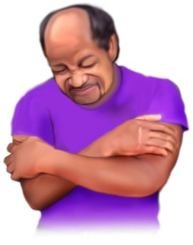  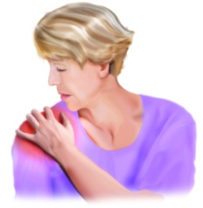  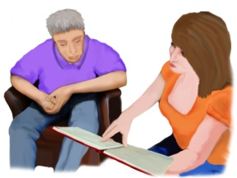  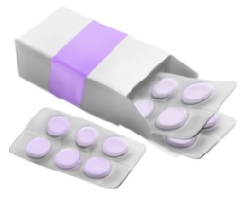  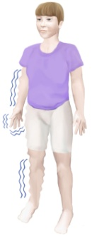  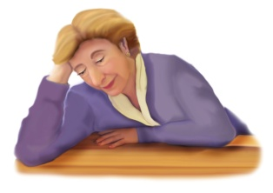  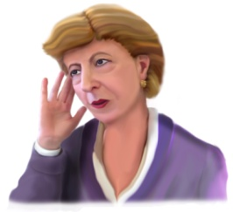  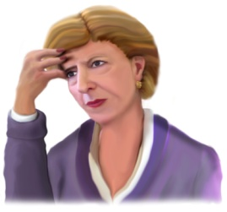  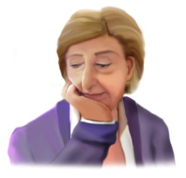  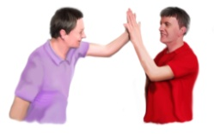  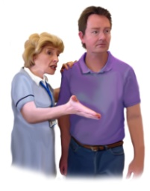  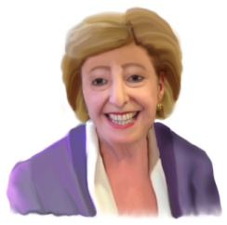  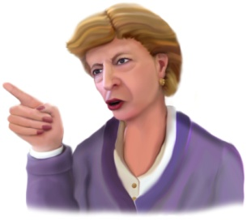  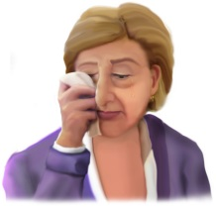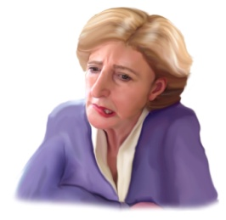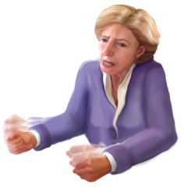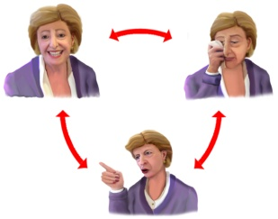 | Every stroke is different  Some people make a good recovery  Some people still have difficulties  Some people have difficulty with eyesight  They may have double vision  They may see half of what they look at  Some people have epilepsy  Some people have pain  Many people have shoulder pain after a stroke  Staff give advice  They tell how to prevent this  They will say how to reduce the pain  There is medicine that can help  Some people feel tingling or numbness  Some people are very tired  Some people can’t remember things  Some people can’t concentrate  Some people have no confidence  Other people still have confidence  Some people have no motivation  A stroke can affect emotions  Some people are happy  Some people are angry  Some people are depressed  Some people are anxious or frightened  Some people are frustrated  Some people change between emotions Stroke can affect social life  Some people feel lonely and left out  It may be difficult to go out and about  or meet friends
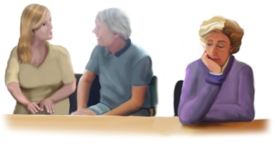

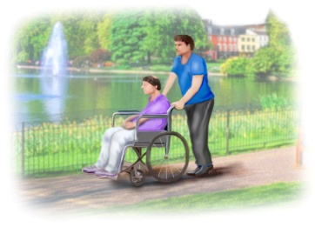
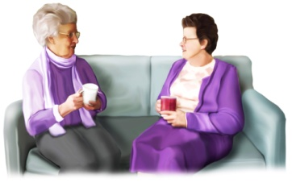
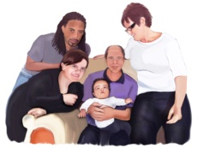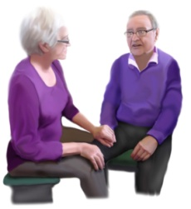 | Stroke affects carers and families  Carers need help too

Getting on with life

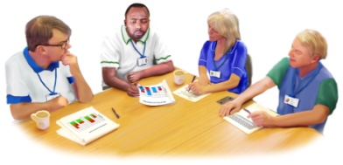  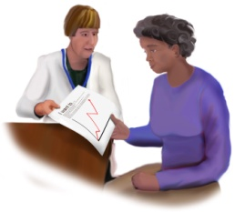 | The stroke team help to set goals  Goals to get back to normal life
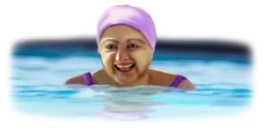  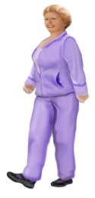  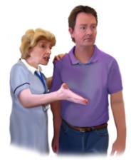  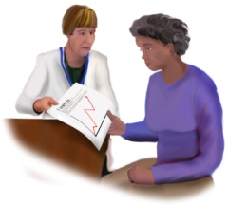  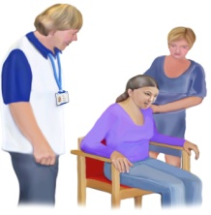 | The goals may include doing sport  It is important to keep active after stroke  This helps rehabilitation  This helps general health  The rehabilitation team will encourage this  A physiotherapist makes an exercise plan  This is for after physiotherapy has ended  They teach how to exercise safely
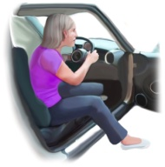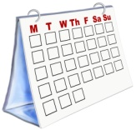  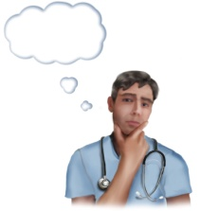 | After a stroke  people must not drive  for at least a month  The doctor decides when to drive again
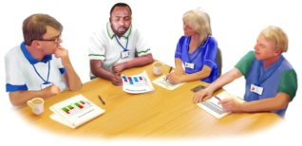  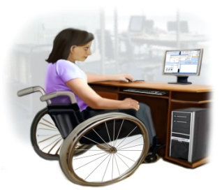 | Some people go back to work  The therapists can help plan  Parts of a job may be difficult  They can talk to an employer  They can teach ways to cope  They know about equipment that helps
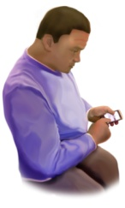 | Some difficulties don't improve  Technology may help some people  There are many ways to use mobile phones  They may help  Apps may help
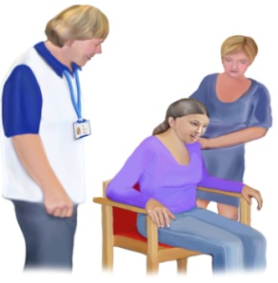  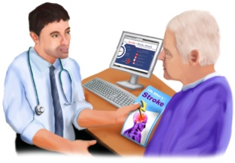 | Therapy will carry on for a while  Then people progress on their own  Family or friends may help  Some people need more support  A GP will know where to get this
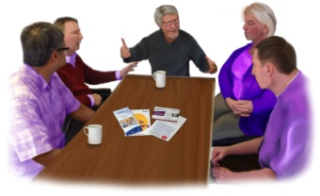  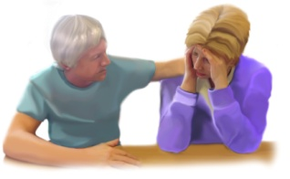  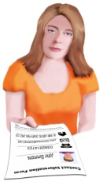  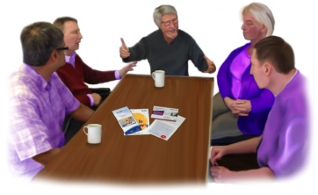  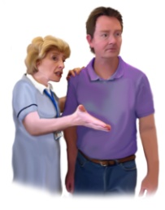 | There are organisations that help  They give support  They help with coping  Meeting others with a stroke can help  The stroke staff know about groups  They give information about these groups  Some groups help communication  The stroke staff support people to go  They encourage people to go
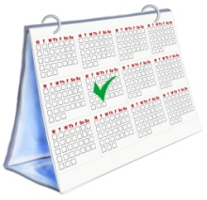  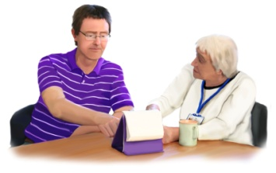 | The staff arrange an appointment  This is 6 months after leaving hospital  The staff find out  how people are managing  whether more help is needed  whether more therapy is needed  There will be another appointment like this  6 months after the first  These appointments happen every year

