

How to use the templates to design your own research information

For any of the forms make sure you follow the guidelines in the aphasia resource pack for how to write in a way easier for people to read.

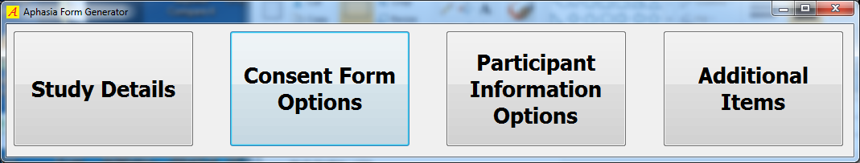

Study details
Click  to insert the basic information about your research which will then be used to populate all your forms thus giving you a set of resources in the same style.
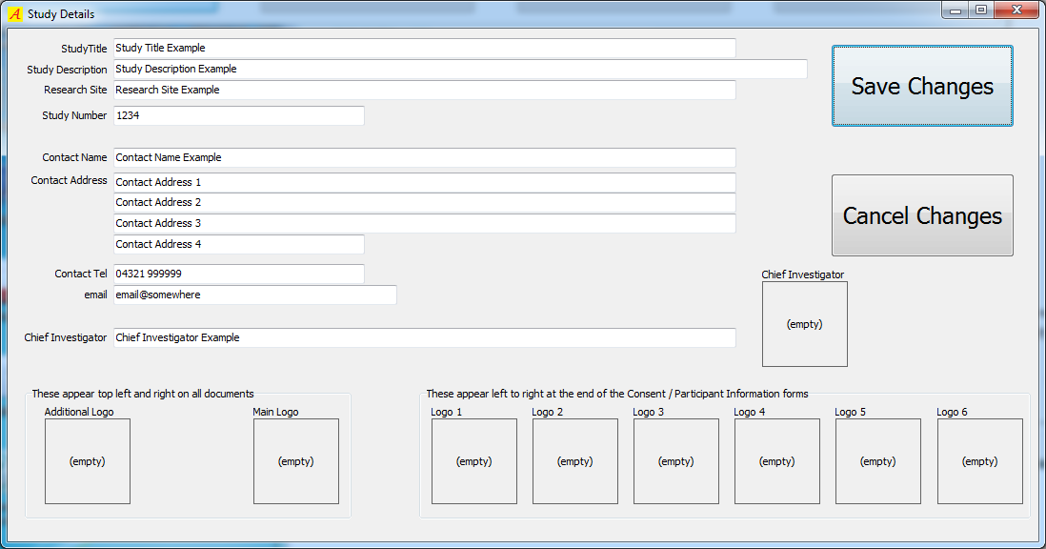
The Study Title is the name of your research
The Study Description space is for a very short explanation e.g. walking after a stroke
Your main and any second logo will appear at the top of the document. Any others will appear at the end.
Text from other sources can be pasted into the text fields using [CTRL+V]
Right click on the image boxes to bring up the image field menu. Select the ‘load from file’ option to upload your image.
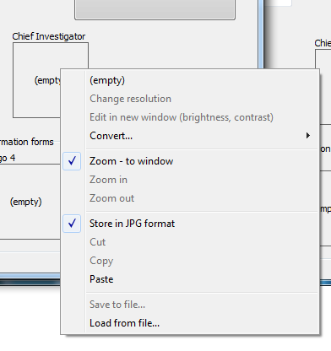
Save your changes.
This information will now be inserted automatically into your consent form, your participant information from and any additional literature you need.

Consent form
Click 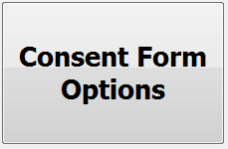.
This form is already populated with the core information required by the ethics process. You can see this by using the preview button.

However, your research may need additional items. The Consent Form window has two tabs. The first shows the available optional items which can be included in the consent form…
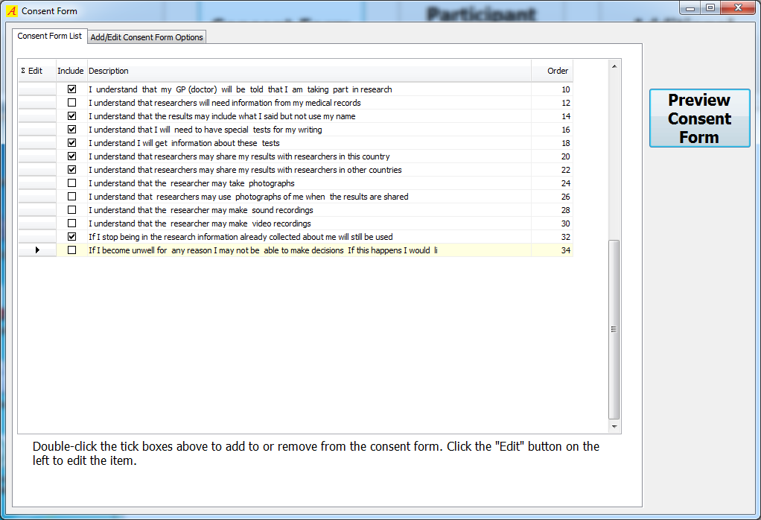
First select from the above boxes which additional items you require; double click the tick boxes under the Include heading to the left of the item to add or remove. You cannot make any other changes using this tab.
Click in the edit box of an item if you want to make any inserts or changes then use the second tab Add/Edit consent from options to insert your information or changes
Use the + box in add/edit tab to insert additional items. You can have as many of these as you need.

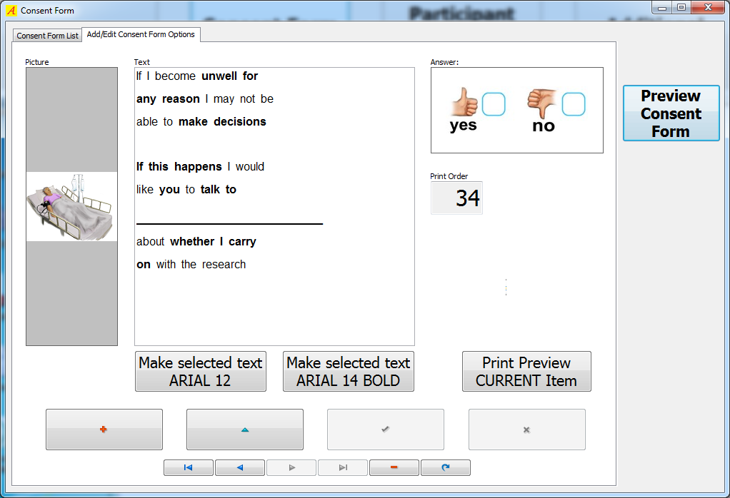
 ADD a new items  EDIT the current item
 SAVE changes  CANCEL changes (don’t save)
Navigates through items
The Picture field can only accept one picture. Use an external program i.e. ‘Paint’ to group multiple pictures and paste the result into the picture field. These pictures will appear printed vertically on the left side of the consent form.
The Text field is deliberately restrictive in terms of font , point size etc. however, if other formatting options are required (colour etc.) then the text can be prepared in another program such as WordPad, then copied and pasted into the text field. Please use 1.5 line spacing and double spaces between words.
The Answer field is automatically filled with a Yes or No option
The Print order field should be a unique number, and dictates the print order of the items on the consent form.

Participant Information forms

Click 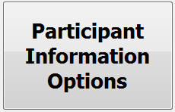
In the Participant Information Form your information will be grouped together under headings which are already listed for you in the add/edit headings tab. These help you to group the participant information and make it easier to understand. Text in the headings is always Arial /16 point/ red. You can add new headings or remove existing ones.
There is space for a picture to go with each heading if you like; this would appear in the printed version after the heading. There is only space for one picture but you can insert multiple pictures by using an external program to group pictures and paste into the picture field.

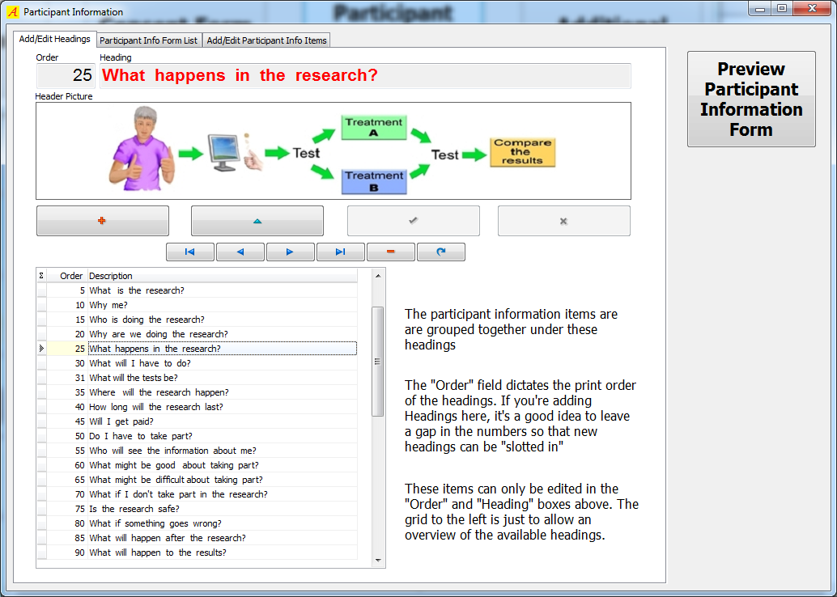
ADD a new items EDIT the current item
SAVE changes CANCEL changes (don’t save)
This panel navigates through items
The Order field dictates the order of the headings for your final form. If you add new headings make sure that each has a unique number, It is a good idea to leave a gap in the numbers so that more headings can be slotted in.
The document is designed to print each heading on a new page. You can change this if you need to after you have saved the whole document into Rich Text Format (RTF).

Next, chose the information to go under each heading. Go to the next tab – Participant Info Form List.

This section is already populated for you with information which has been designed by people with aphasia to explain the basic stroke story and the research story in a way which is easy to understand. Use this text if you can. However, you can alter this or add text as your research dictates. Double click the items to remove any you don’t need.

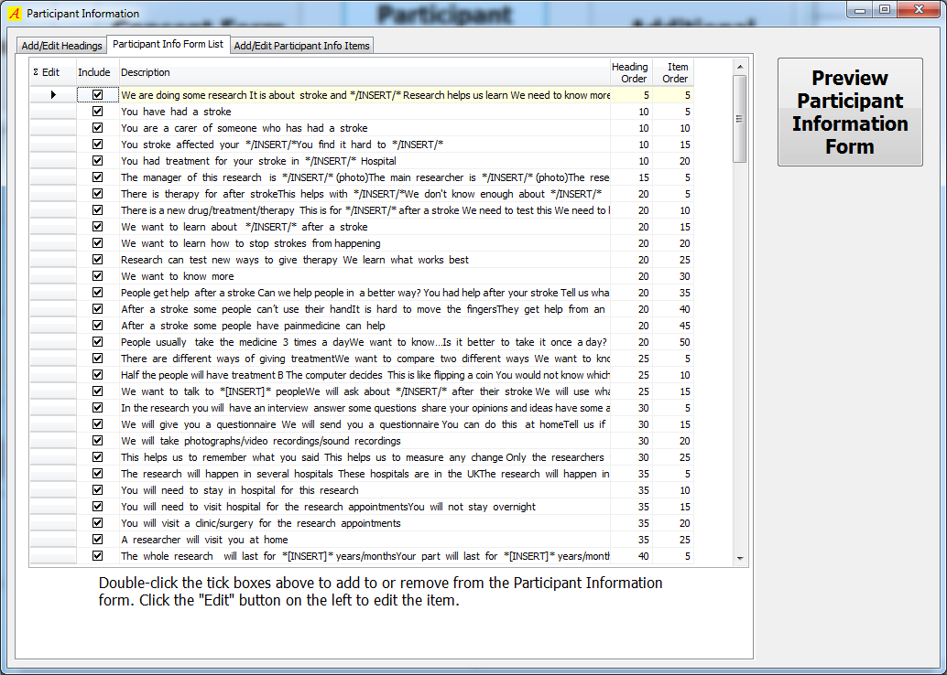

Use the third tab to edit this information. 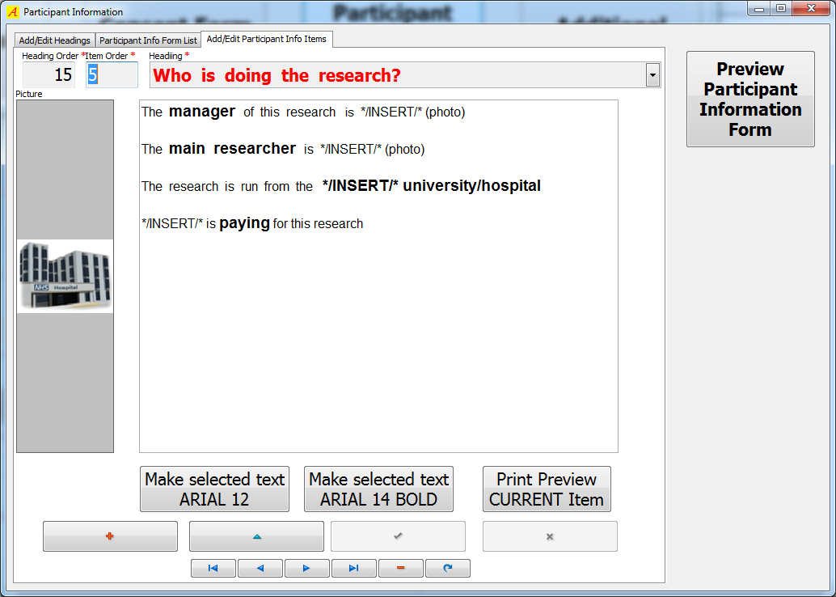

You need to make sure that your information is in a logical order. The Heading order field is automatically filled. The Item order field can then be used to dictate the print order of items within the group. The combination of your heading order and print order should be unique.

Additional forms

Use the header and footer for any additional forms for your research e.g. appointment letters, reminders, posters for meetings.

Please refer to the full text in the aphasia resource pack for instructions in designing these forms and examples of good design.

Click 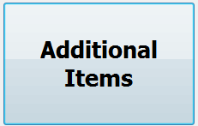 to go to the Other forms window.
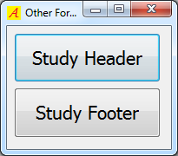
A Study header or footer can be produced. By clicking on the disk icon you can save the header/footer in RTF format

This can then be copied and pasted into your own documents i.e. appointment letters.

